North Ceredigion Fitness Website Prototype Development

Contents

Task Analysis 2

Rich Picture 2

Use Case 3

Data Flow Diagram 4

State Transition Diagram 5

Website Plans 6

Home Page 6

About Page 7

Venues 8

Our Staff 9

Classes 10

Admin Page 11

# Task Analysis

For the Task Analysis, I have used the lecture slides as a reference in order to have four main parts: the Rich Picture, Use Case, Data Flow Diagram and State Transition Diagram. These diagrams will be illustrated below.

## Rich Picture

The below image displays who and what is involved within this project. As displayed below, there will be three main users; the administrator, instructor, members of the public. These members of the public can create an account and become a member of the public with an account; however they will still be the same user. Administrators, reassigned annually, and instructors can manipulate classes, while the members of the public can view them. Signed in members of the public can enrol for them.

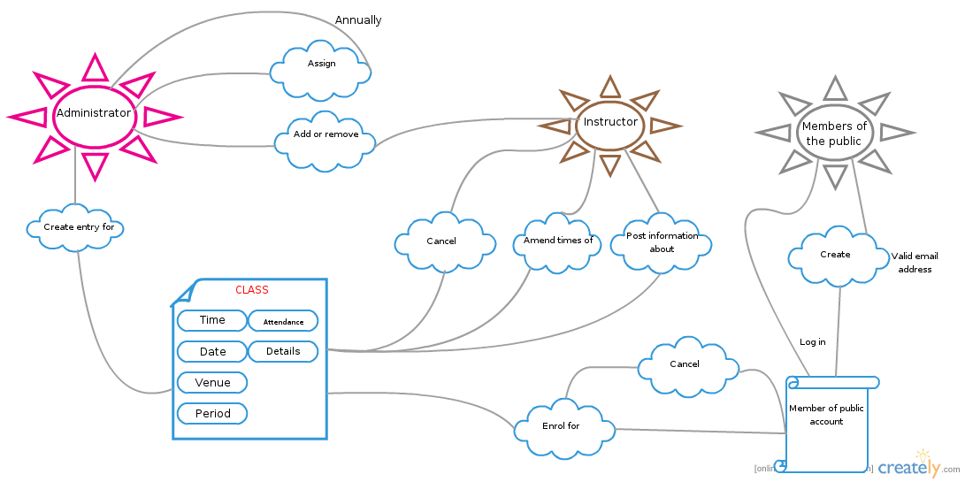

## Use Case

The below diagram displays what the types of memberships can do what within the website. The diagram also displays that an administrator can inherit all abilities of an instructor. The member of public signed in can also make use of all the abilities of the member of public.

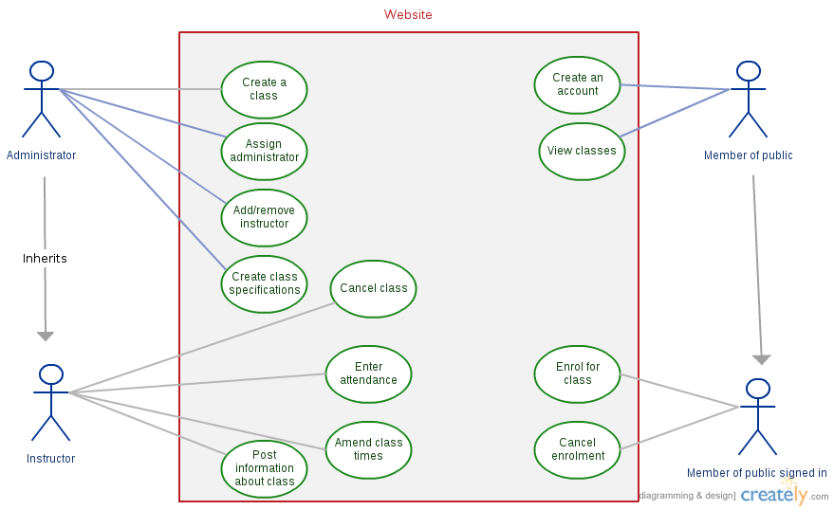

## Data Flow Diagram

The below diagram displays how data will flow through the system, and the course of actions for the users. Inheritance is displayed within this diagram too.

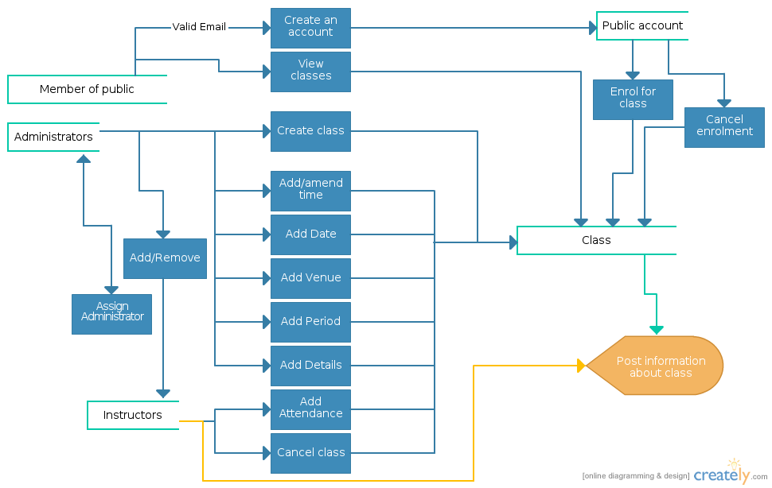

## State Transition Diagram

The below diagram displays all of the different states within the system. It will display how the states change due to actions by users, and displays all the possibilities of these actions.

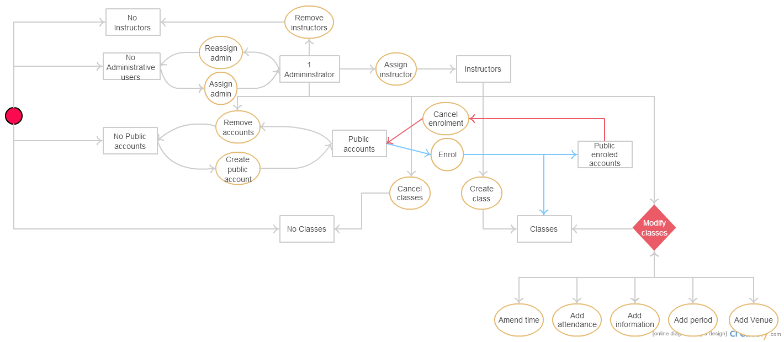

# Website Plans

For my design of the website, I tried to keep all of the pages consistent. That is why most of these plans will look alike. Regardless, some of these plans are not how the website actually looks, due to changes during the website life cycle.

## Home Page

I actually added a feature in the website to display when classes have been cancelled/added.

North Ceredigion Fitness | Links to other pages

Login

Headline(s) - what the website does

## About Page

About this website

Login

North Ceredigion Fitness | Links to other pages

## Venues

I actually chose to change this layout to a different page for each venue as it was easier to use for the user, however this is the original plan.

Login

North Ceredigion Fitness | Links to other pages

All of the venues that this company operates at

## Our Staff

Login

North Ceredigion Fitness | Links to other pages

Images and descriptions of all staff

## Classes

Login

North Ceredigion Fitness | Links to other pages

Details about all classes

## Admin Page

Buttons for all abilities of admin

Login

North Ceredigion Fitness | Links to other pages

# Prototype

<http://users.aber.ac.uk/chh57/CS22310/Home.html>

# Sources

For this project, I used Bootstrap: <http://getbootstrap.com/>

And some of my CSS from another of my web assignments.

# Evaluation of Prototype against Shneiderman’s 8 Golden Rules

These rules were obtained from the text ‘Designing the User Interface’ by Ben Shneiderman.

From: http://faculty.washington.edu/jtenenbg/courses/360/f04/sessions/schneidermanGoldenRules.html

## Strive for Consistency

As stated above, many of my designs repeat the same layout. This is due to my attempt at fitting these eight rules, the first one being most relevant. Each one of the web pages, apart from the first one (which is different to catch the users’ eye) has the same layout. Every single page has the same toolbar at the top, in order to achieve consistency. Also, if there is repeating aspects of the web page, such as the login, this will be in the same position over all of the web pages.

In terms of font, all fonts are the same except for the Carousel text on the front page (which, as stated before, is different to catch the users’ eye).

## Enable frequent users to use shortcuts

When the website actually has functionality, it will have to aspect to which signed in users will be able to view their most visited web pages within the domain in the toolbar at the top (there is actually space for it). Other than this, there are links on every page to every other page in the domain in the toolbar, so navigation is implemented with ease of use in mind.

## Offer informative feedback

On the toolbar on all of the pages, there is a button for feedback. At any time, this (when function is added) will execute a javascript function that will allow the user to present their honest feedback. It can be done anonymously by people that are only there to view classes.

## Design dialog to yield closure

This rule has been met by ensuring each web page can be completed one by one. For example, the user is not led to another full of hundreds of other tasks; they can complete the web page and then navigate to another once completed, if they want. This includes the administrator; they can complete their task on the admin page and halt their use of the website immediately if they so wish.

## Offer simple error handling

With this assignment, there are not many places for the user to make a serious error. The public user cannot do anything except view the website and enrol for a class (enrolling is possibly the only place one could find a serious error in a website, but not this one). When they enrol, they cannot complete the enrolment unless all the forms are filled out. This means that nothing can be damaged in this area. Other than this, the admin/instructor is the only one with sufficient rights to cause an error. When classes are manipulated or the system is edited by one of these, there are no errors that can be made in order to cause a serious issue.

## Permit easy reversal of actions

This rule has been supported by the specification of the website. It is already implemented; the fact that the user can cancel their enrolment for a class ensures that they can reverse their actions. Other than this, removal of their account is supported, whether it is by them or the administrator. The administrator is able to reverse any action they carry out; whether this is cancelling a class or anything else.

## Support internal locus of control

The website will not automate any actions- it has been coded so that nothing is automated except for the scrolling within the Carousel. If the user wishes to take action within the website, they must click something first.

## Reduce short term memory load

The user need not remember any details for the use of this website, except their user details. All data can be found within the website; whether this is the location of the venue, details of the class or details of the staff. There is no data within the webpage that is required in order to access another location within the domain. For example, the information on the about page need not be remembered in order to access any other abilities within the domain.

## Justification & Conclusion

I chose to use Bootstrap as recipients of this assignment were ensured that we could use any library to hand, and Bootstrap provides a clean, user friendly interface that is relatively fast to use. The Carousel is used here because it is aesthetically pleasing, and provides a lot of information without loss of space. It was actually the first time I’ve used Bootstrap and, as a result of this assignment, it looks like I’ll be using it again.

To conclude, I believe this assignment has been completed to the mark scheme and that I am happy with the way my website looks. I have used the slides provided by the lecturers to create a report that is not overloaded with information, however supplies the reader with all the relevant data (whether this be images or information). The designs and implementation went fairly smoothly due to ensuring consistency across the website. The user is even welcomed on mobile devices, as specified in the mark scheme. If I were to re-do this assignment, I would attempt to personalise Bootstrap even more to ensure a unique finish to the website.